Assessment Committee Notes 11-29-21

Agenda:
- Continue review of NWCCU rubric for student learning
- Decide next steps regarding a gen ed subcommittee
- Confirm meeting time for next term

Review NWCCU Rubric for Student Learning
https://nwccu.org/tools-resources/institutions/accreditation-handbook/ - see table of contents and click on Appendix C or go to page 61
Discussion Questions:
- Do the criterion descriptions make sense? Is anything unclear?
- At what level would you rate CCC on this criterion in the rubric and why?
- What evidence could we show for this rating, if any?
- What problems would indicate that this criterion is not well developed at CCC?
- Other comments or questions?

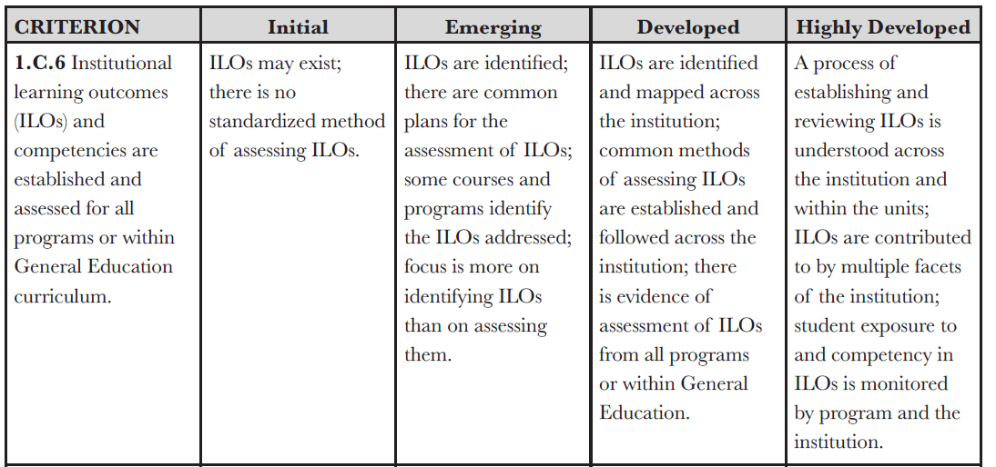
Discussion of 1.C.6:
- Speaks to the need for a coordinated effort across the institution. Working within a shared framework. We might have a tendency to be siloed.
- “Common methods of assessing” - does this mean common within a program or across the college? Common way doesn’t necessarily mean we are doing it the same. It can mean working together for the sake of the institution, not just for the sake of the program.
- Our report template lists options that trace back to good practice and professional development; they serve as a reminder of guardrails. This is our common framework.
- How do we map gen ed currently?
- Does some of this mapping show up in the Guided Pathways process?
- Recent discussions about why courses are attached to gen ed outcomes and why.
- Currently it seems that more often folks start with assigning the letter for gen ed (for transfer) (C=course completely aligns, P=partially aligns) based on wanting/needing the course to count for gen ed, not necessarily based on the course being designed to help students meet the learning outcome. We don’t have a definition of what it means to “completely” meet this outcome. Hopefully the gen ed application revision that’s underway will help improve this.
- The state gen ed outcomes are set; we can’t change them. Some teams create working definitions and descriptions to operationalize them.
- Student competency is only mentioned in the highest level of the rubric.
- It would be a cultural shift for us (the college) to discuss student results beyond the program.
- What would it look like to have competency “monitored by the institution”? Accountability could mean faculty having cross-disciplinary conversations as a way for faculty to monitor and collaborate.
- Consider the relationship of accountability to the goal of strong engagement. Make sure accountability doesn’t undermine engagement.

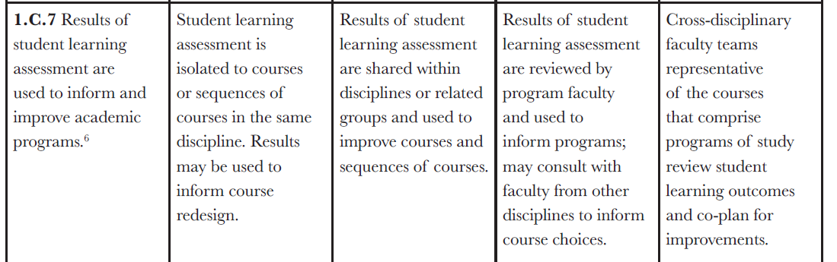

Discussion of 1.C.7:
- The different levels seem to delineate scope of sharing and siloing.
- What does it look like to consult faculty from other disciplines? Is this referring specifically to faculty in different disciplines that contribute to a degree and/or to a gen ed area?
- Math 50 is in so many programs - are conversations going on there? Guessing that conversations happen less in gen ed than in degree programs.
- Cultural Literacy seems to be a good example of bringing together different departments.
- We’re good at coming together when we have a problem to solve, but then we go our separate ways.
- Good place for EFA structure to be able to bring this
- No mention of resourcing or sustainability in the rubric. The follow-thru piece is not built into our institutional practices/structures/resourcing.
- We put a lot of energy and resources in the input stage.
- It’s not student centered if it ends with input.

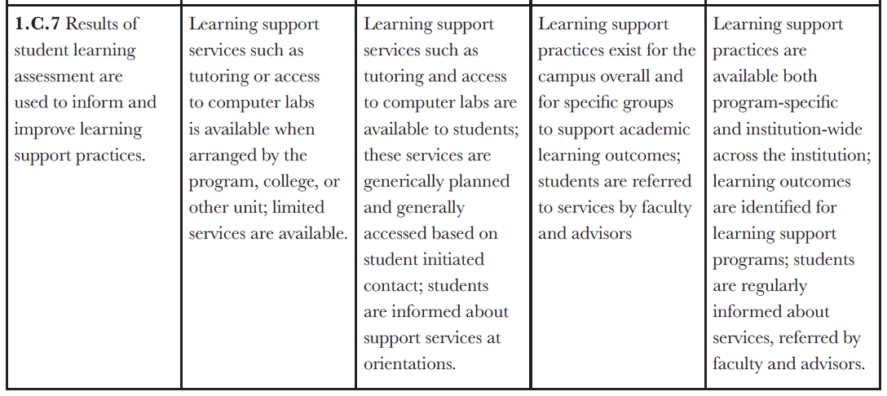
We ran out of time to talk about the second part of 1.C.7, learning support practices

Gen-ed Subcommittee Next Steps
- Write up a charge and specific tasks for the group.
- Note: The subcommittee members will be welcome to attend whole-committee meetings but would not need to unless relevant gen ed topics were on the agenda (like updates on the subcommittee’s work).
- Contact transfer gen ed assessment team leads and key folks in related instruction/assessment to ask if they or someone they recommend could join the subcommittee. Before the end of Fall term, send an email heads-up/please think about this/more to come. Then email again early Winter term with the request.
- Elizabeth will draft something and send it out for review.

Next Term Meeting Time
Consensus is to continue meeting every other Monday at noon for one hour.

